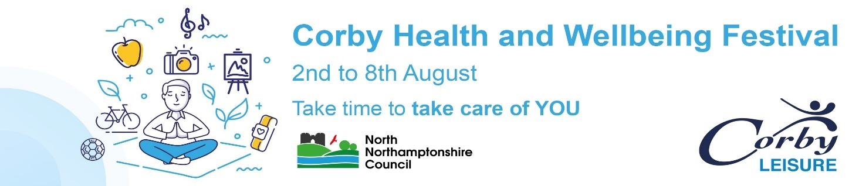
“We hope you have enjoyed our event. We would really appreciate you completing a really quick survey about your experience”
- Which session/s have you attended? Which day?
______________________________________________________________________________________________________________________________________________

- How likely are you to attend this session again? (Please tick)
Very Likely
Likely
Unlikely

- How would you rate the following? (Please tick)
 | Excellent | Very Good | Good | Fair | Poor
Instructor / Host / Speaker
Enjoyment Value
Content of Session
Overall Impression

- How likely is it that you would recommend this session to a friend or colleague?

(1 = not at all likely; 10 = extremely likely)

1 | 2 | 3 | 4 | 5 | 6 | 7 | 8 | 9 | 10

- Will you engage in next year’s event?
Very Likely
Likely
Unlikely

- Any other comments:
____________________________________________________________________________________________________________________________________________________________________________________________________________________________________________________________________________________________
Thank you for taking the time to complete a quick survey about your event experience.
Please hand back to your session leader or forward to Corby Leisure via email – cultureleisure.cbc@northnorthants.gov.uk or post to Corby Leisure, Deene House, New Post Office Square, Corby, Northants, NN17 1GD

